22 March

Lesson Plan

- Download PHPMailer and extract from Github
- Move and extract the folder to your register form folder
- Send an email with PHP and your google account
Generate an app password for your gmail account
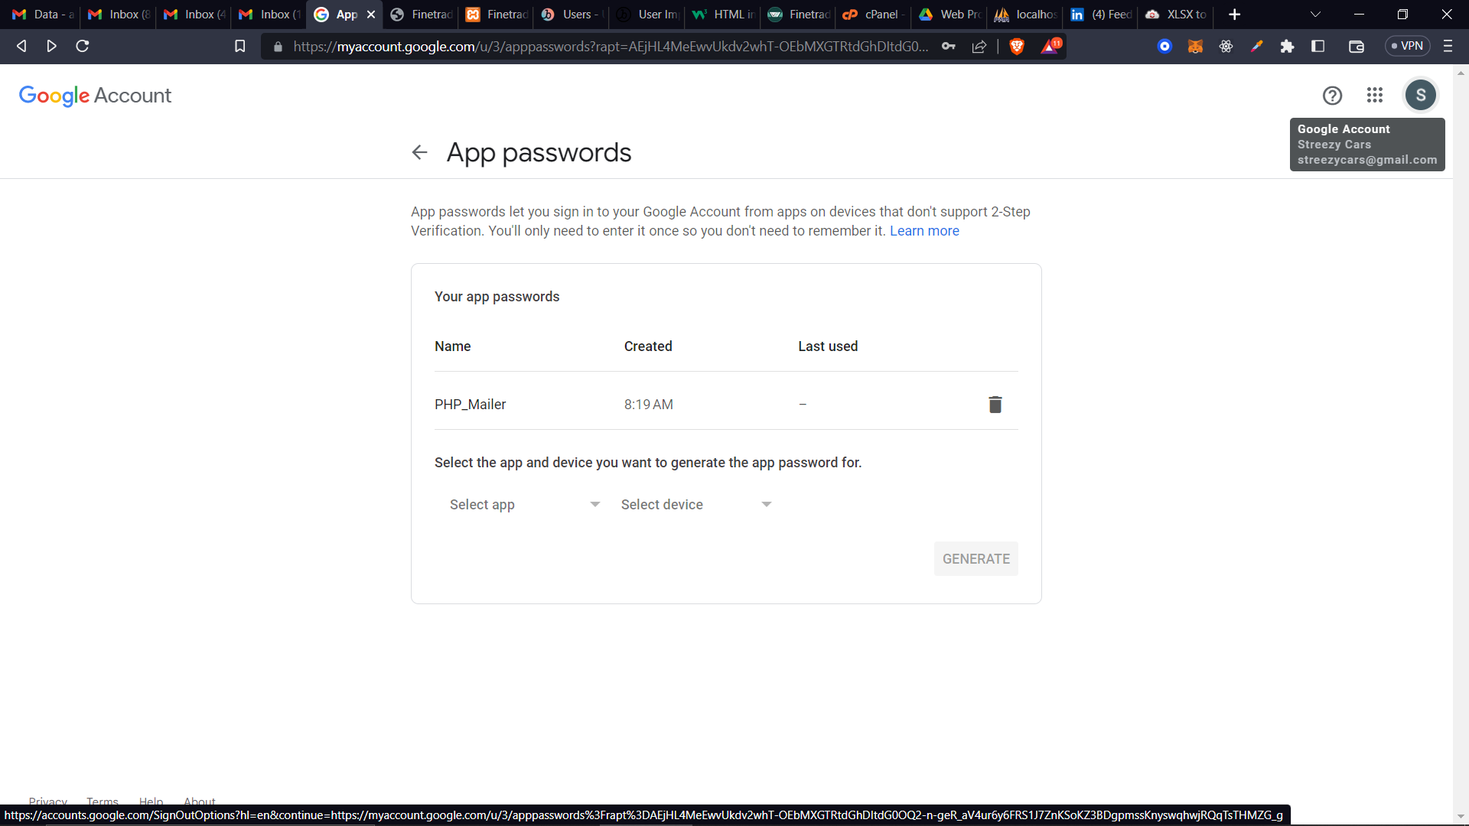
- Send a welcome email on sign up
- Research : SPF DKIM DMARC

